CNS-CP Recertification Log
Name:

CNS-CP recertification in 2024 is by paper application only. All contact hours and activities must have been
Completed between January 1, 2019, and December 31, 2023.

The CNS-CP recertification program recognizes that advanced practice competency is maintained in a variety of ways through successful participation in various professional activities. In addition, results of the CNS-CP exam are incorporated into the next recertification cycle’s plan. This log provides the means for tracking required continuing education and activities and must be submitted along with the CNS-CP recertification application and the appropriate fee. Please read all information thoroughly before beginning your log to ensure that you understand the requirements. If audited, the acceptable documentation listed for each activity must be submitted. For additional information on recertification, please refer to the CNS-CP handbook here.

- Completion of professional activities related to goals as determined by learning plan.
- A minimum of 300 points must be accrued. Points do not need to be accrued in all activities.

Use the following log to track your contact hours and activities.

CONTINUING EDUCATION

Continuing education must include a minimum of ten contact hours (20 points) of APRN-approved pharmacology continuing education offerings. Each approved contact hour is equal to 2 points.

The same pharmacology-approved contact hours may be used for both CNS-CP and primary CNS (population focus) recertification.

The same contact hours/activities cannot be used for both CNS-CP and CNOR recertification. The same contact hours
cannot be used for both the pharmacology requirement and those used to meet competency requirements for the
learning plan.

CME Credits
CNS-CPs are responsible for converting CME credits into contact hours using the ANCC conversion of:
1 CME credit = 1 contact hour=2 points

Program Title | Date of Program | Name of Provider | Program Accredited By | Contact Hours Awarded | Pharm Contact Hours Y/N

TOTAL: Contact Hours

Acceptable documentation (only if audited): Copy of certificate(s) of attendance from an acceptable provider.

Accredited, Approved Providers for Contact Hours
Contact hours approved by any of the following groups are acceptable:
- Any organization approved by Accreditation Council for Pharmacy Education (ACPE).
• American Nurses Credentialing Center (ANCC)
• An agency, organization, or educational institution accredited by ANCC
• Any State Board of Nursing
• Any state nurses’ association
• Association of periOperative Registered Nurses (AORN)
• American Association of Critical-Care Nurses (AACN)
• American Association of Neuroscience Nurses (AANN)
• American Association of Nurse Anesthetists (AANA)
• Association of Women’s Health, Obstetric, and Neonatal Nurses (AWHONN, formerly NAACOG)
• American Academy of Family Practitioners (AAFP)
• American Academy of Nurse Practitioners (AANP)
• American Academy of Physicians Assistants (AAPA)
• American College of Nurse Midwives (ACNM)
• National Association of Clinical Nurse Specialists (NACNS)
• National Association of Nurse Practitioners in Women’s Health (NPWH)
• National Association of Pediatric Nurse Associates and Practitioners (NAPNAP)
- Accreditation Council for Continuing Medical Education (AACME) AMA PRA Category 1 CME
- American Health Information Management Association (AHIMA)

PROFESSIONAL ACTIVITIES
CNS-CP certificants may choose from a variety of professional activities in which to meet the goals outlined in the learning plan. A maximum number of points are allowed for each activity. CNS-CPs must earn a minimum of 300 points to recertify their credential. These points are in addition to any CE requirements noted above. All activities must be earned between Jan. 1, 2019 and Dec. 31, 2023. The same activities cannot be used for both CNS-CP and CNOR recertification.

Academic study-graduate or post-graduate level-Maximum of 100 points Acceptable documentation (only if you are audited): Copy of unofficial transcript Conversion rate for academic credits:
1 semester hour/credit | 15 points
1 quarter hour/credit | 10 points

Name of University | Title of Course | Semester/Quarter Hours Earned | Year | Points
TOTAL: POINTS (not to exceed 100)

Service as a Board Officer or Committee Member (e.g., facility APRN committee, NACNS or AORN APRN Specialty Assembly or task force)-Maximum of 60 points

Acceptable documentation (only if audited): Board report, minutes, committee report, or other documentation validating participation on committee; minimum four contacts/year.

Committee Position Held | POINTS AWARDED
International, national, or state board member | 30 points/year
Local or facility level | 15 points/year
CCI Board of Directors | 50 points/year
CCI Certification Council | 50 points/year

Title of Board/Committee | Role on Board/Committee | Level of Committee (e.g., local,national) | Dates of Service | Points
TOTAL: POINTS (not to exceed 60)

Clinical inquiry (EBP projects/research)-Maximum 80 points
Acceptable documentation (only if audited): A final report which summarizes evidence of participation in a research project or study, including its impact on current practice/patient outcomes.
Primary investigator | 50 points
Co-investigator or Project Lead | 30 points

Title of Project | Name of Facility | Level of Participation | Points
TOTAL: POINTS (not to exceed 80)

Instructor, Academic Program-Maximum 90 points
Acceptable documentation (only if are audited): Course description, syllabus with course objectives, number of credits, and methods of evaluation. If your name does not appear as the instructor in the syllabus, a signed letter from the department chair on official school letterhead attesting to serving as instructor will suffice.

Conversion rate for teaching:
1 semester hour/credit | 15 points
1 quarter hour/credit | 10 points

Name of University | Title of Course | Semester/Quarter & Year Taught | Points

Precepting Advanced Practice Student-Maximum 60 points
Acceptable documentation (only if audited): Letter from sponsoring institution (on official school letterhead and signed by faculty or department chair) indicating responsibilities as preceptor and dates/hours
of preceptorship.

Conversion rate for precepting:
1 semester hour/credit | 15 points
1 quarter hour/credit | 10 points

Student’s initials | Name of University | Title of Program | Semester/Quarter & Year Precepted | Points
TOTAL: POINTS (not to exceed 60)

Presentation for an advanced practice audience, non-academic (professional nursing organization, e.g., NACNS, AORN)-Maximum 50 points

Acceptable documentation (only necessary if you are audited): Flyer, brochure, handout, or website link with title of presentation, objectives, and outline of content. If poster is submitted, provide a picture of completed work with proof of acceptance at conference.

Type of Presentation | POINTS AWARDED
Podium presentation (minimum 30 minutes in length) | 30 points
In-service (minimum 30 minutes in length) | 25 points
Remote presentation (i.e., webinar, teleconference, etc.) (minimum 30 minutes in length) | 20 points
Poster presentation | 20 points

Title of Presentation | Name of Conference | Date of Presentation | Length of Presentation | Points

Author (book, journal article, patient/family educational materials)-Maximum 75 points

Acceptable documentation (only if audited): Copy of title page, table of contents, or abstract that includes your name as contributor and the publication date. A copy of the publisher notification of acceptance is required if the publication date occurs after the recertification cycle.

Type of Publication | Points Awarded  Primary author, chapter in book
Primary author, chapter in book | 50 points
Secondary author, chapter in book | 30 points
Subject matter expert or reviewer for journal article or chapter in book | 20 points
Author, book review | 20 points
Doctoral dissertation | 100 points
DNP capstone project | 75 points
Editorial, peer-reviewed professional journal | 30 points
Primary author, peer-reviewed professional journal article | 50 points
Secondary author, peer-reviewed professional journal article | 30 points
Development of patient education tool or healthcare professional fact sheet | 20 points
Guest Editor, Peer-Reviewed Journal Issue | 50 points

Title of Publication | Type of Publication | Contributing Role | Year Published | Points
TOTAL: POINTS (not to exceed 75)



Volunteer, CCI test development committee-Maximum 50 points

Acceptable documentation (only if audited): CCI acceptance letter

Committee | Point Value
Job Analysis | 100 points
Task Force (in-person) | 25 points
Survey Completion (remote) | 5 points
Survey Review Call | 10 points
Pilot Survey Review Call | 10 points
Subgroup Analysis Call | 15 points
Test Specs (in-person) | 25 points
Crosswalk Call | 10 points
Item Writer (in-person) | 30 points
Item Writer (remote) | 0.5 points/item
Cut Score/Standard Setting | 30 points/appointment
Item Review (in person) | 25 points
Item Review (remote) | 15 points
Form Review (in-person) | 25 points
Problem Identification Notification (PIN) | 10 points
Alternate | 5 points
Other: Ad Hoc Committee (specify) | 15 points

Committee Name | Date(s) of Meeting | Points

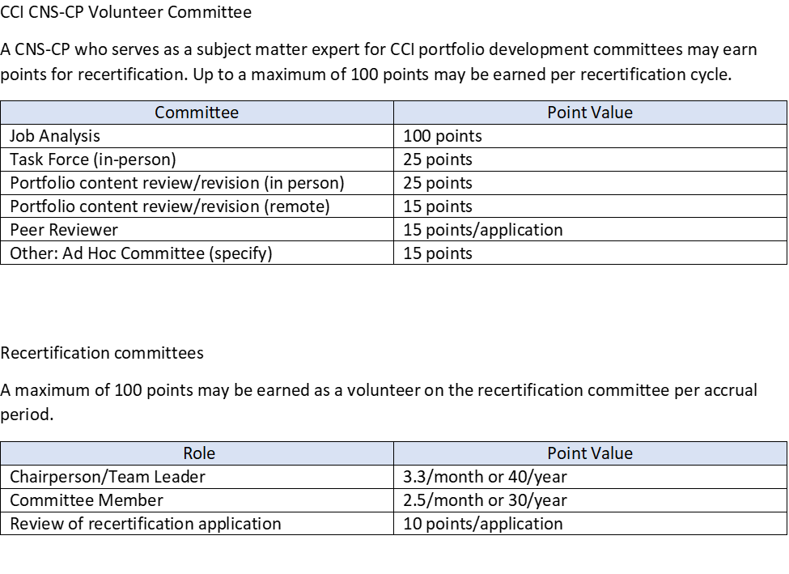

Committee Name | Date(s) of Meeting | Points

TOTAL: POINTS (not to exceed 100)

APRN (CNS) primary certification/prescriptive authority achievement/maintenance- Maximum 45 points

Acceptable documentation (only if audited): Copy of certificate or wallet card

Primary APRN (CNS) Certification | Points Awarded
Initial APRN (CNS) primary (population focus) certification | 30 points
Maintaining APRN (CNS)  primary (population focus) certification | 20 points/renewal period
Attaining/maintaining prescriptive authority | 15 points/renewal period

Type of Certification | Date | Points
TOTAL: POINTS (not to exceed 45)

Attain/Maintain Perioperative-Related Certification

A maximum of 100 points may be earned for earning an accredited perioperative-related certification or completing the recertification process for an accredited perioperative-related certification. Examples of accredited perioperative-related certifications include CAPA, CPAN, CRCST, or ABCGN. Accreditation by ANSI, ABSNC, or NCCA will meet these criteria.
This list is not intended to be all-inclusive. Other accredited certification deemed equivalent by the CEO of CCI in consultation with the Credentialing Manager may be accepted.

Attain/Maintain an Accredited Perioperative Certification
Initial Certification | 30 points
Completion of Certification | 20 points

Name of certification | Accrediting Body | Valid through (provide dates) | Points
TOTAL: POINTS (not to exceed 100)

Professional Perioperative-Related Volunteer Service

A maximum of 100 points may be earned for medically-related volunteer service activities. Examples include surgical mission trips and service at medically underserved clinics.
Event Type | Point Value
Local | 5 points/activity
Regional | 5 points/activity
State | 15 points/activity
National | 20 points/activity
International | Participant = 25 points/activity  Leadership role = 50 points/activity

Sponsoring agency | Date of service | Points
TOTAL: POINTS (not to exceed 100)

Earning another Accredited Perioperative Certification

Training Certificates
A maximum of 30 points may be earned for certificates of training by an approved provider (e.g., American Heart Association, American Red Cross, or Military Training Network) including initial and renewal certificates within the accrual period. One initial training and one renewal per certificate type may be reported within one accrual period. If audited, must provide a copy of the certificate of completion.

- BLS = 5 points
- ACLS = 10 points
- PALS = 10 points
- NRP = 10 points
- Non-CE, live taught perioperative training program = 10 points
  - Examples include laser training, Da Vinci Robotics training, and informatics training.

- Other training may be approved by CCI on a case-by-case basis. Documentation must be provided to CCI for review.

Additional Points Activities
A maximum of 50 points for patient or staff education tools. If audited, must provide a copy of the education tool.
Name of tool (specify if patient or staff education) | Points | Date
 | 25
 | 25

TOTAL: ____POINTS (not to exceed 50)

WAIT! Did you:

- Complete all sections of your recertification l og?
- Return all forms
  - Self-assessment
  - Learning plan
  - Recertification log
  - Peer review forms X2
  - Reflection form
- Fill out the application form?
- Include payment?
TOTAL: ____ POINTS (not to exceed 30)

TOTAL: POINTS IN LOG (must have minimum of 300)

Please mail all documents in a single envelope to: CCI
Attn: CNS-CP recertification
400 Inverness Parkway, Suite 265
Englewood, CO 80112

